**Lab Report: 209L – 01 Ngyuen**

**Gene Drumheller**

**Experiment 4**

**Transfer Functions**

**Objectives:** To calculate and measure the frequency response of RLC circuits

**Equipment’s Used:**

* Oscilloscope
* AC Voltage Generator
* Multimeter
* Capacitor-Inductor Meter
* Clip leads
* BNC Cables
* Resistor (1kΩ and 10kΩ)
* Capacitor (two 33.8µF)

**Prelab:**

Attached at end of the report.

**Lab:**

**Part 1**:

Measure your resistor and capacitor values:

Measured resistor value 1 = 380.0Ω

Nominal resistor value 1 = 390.0Ω

%difference = $\frac{380-390}{390} x 100 \%= -2.564\%$

Measured capacitor value 1 = 32.6nF

Nominal capacitor value 1 = 33.8nF

%difference = $\frac{0.326-0.338}{0.338} x 100 \%= -3.55\%$

Measured capacitor value 2 = 34.6nF

Nominal capacitor value = 33.8nF

%difference = $\frac{.346-.338}{.338} x 100 \%= 2.367\%$

Capacitor combination in serial = 16.8nF

Nominal value = 16.4nF

%difference = $\frac{.168-.164}{.164} x 100 \%= 4.85\%$

Nominal value Inductor = 10mH

Table 1: Measurement of tools

|  |  |  |  |
| --- | --- | --- | --- |
|  | Measured | Nominal | %difference |
| Resistor | 380.0Ω | 390.0Ω | -2.564% |
| Capacitor | 16.8nF | 16.4nF | -4.85% |
| Inductor | - | 10 mH |  |

**Part 2:**

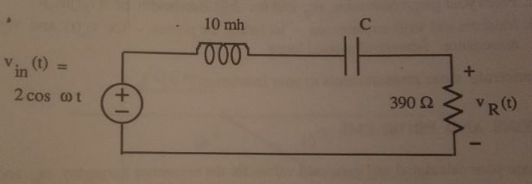

Figure 1: Circuit 1

Step 1) Finding the Resonance Frequency and Capacitor value

The Resonance Frequency =

$$\left|G\left(jw\right)\right|= \frac{R}{\sqrt{R^{2}+{\left(wL-\frac{1}{wC}\right)}^{2}}}$$

The maximum is simply that frequency where

$$\sqrt{R^{2}+{\left(wL-\frac{1}{wC}\right)}^{2}}$$

The minimum, is where

$$wL-\frac{1}{wC}=0$$

Which implies

$$w= w_{0}=\frac{1}{\sqrt{LC}}$$

From page 12 – 12:

$$V_{L}\left(jw_{0}\right)= -V_{c}\left(jw_{0}\right)=j\sqrt{\frac{L}{C}}*\frac{V_{in}}{R}=\frac{V_{L}\left(jw_{0}\right)}{V_{in}}=j\sqrt{\frac{L}{C}}*\frac{1}{R}$$

Since,

$$\left|\frac{V_{L}\left(jw_{0}\right)}{V_{in}}\right|=2, j\sqrt{\frac{L}{C}}*\frac{1}{R} =2$$

$$4=\frac{L}{C}*\frac{1}{R^{2}} → C*\frac{1}{4R^{2}}=16.4nF$$

Finally,

$$w_{0}=\frac{1}{\sqrt{LC}}=\frac{1}{\sqrt{{10}^{-2}*16.4*{10}^{-9}}}= 78086 rad/s$$

$$F_{0}=\frac{78086}{2π}=12427.9 Hz$$

Step 2: Measure for Gain

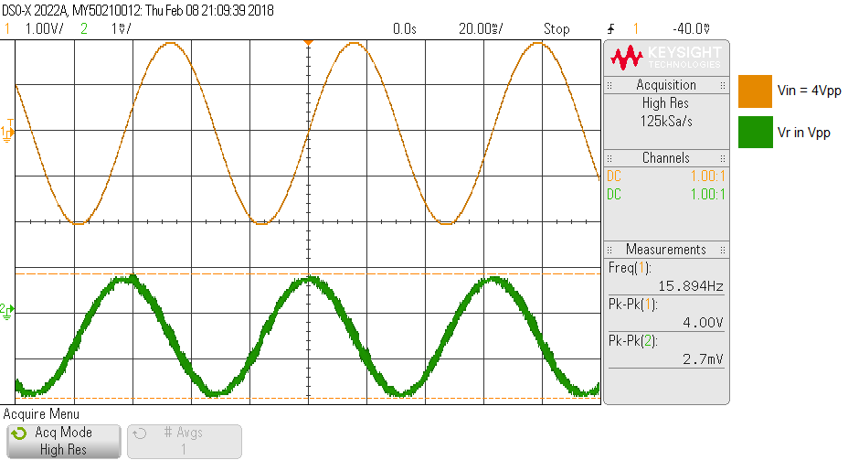

Graph 1: Measurements of Vin(t) and Vr(t) at F = 15.9Hz

Vin(t) = 4.0Vpp, Vr(t) = 0.0027Vpp, Gain = 0.000675

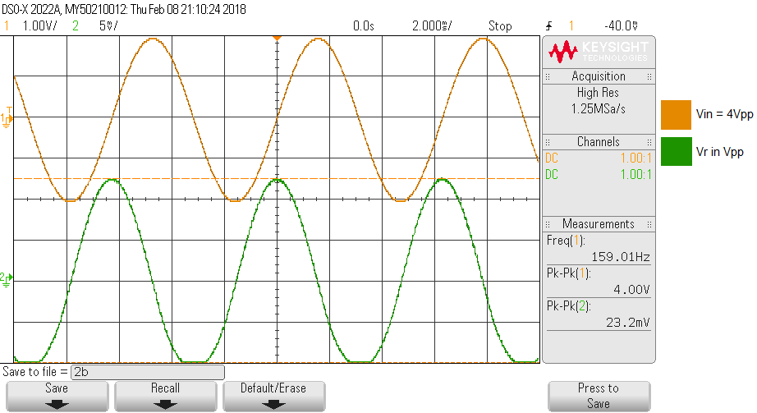

Graph 2: Measurements of Vin(t) and Vr(t) at F = 159Hz

Vin(t) = 4.0Vpp, Vr(t) = 0.0232Vpp, Gain = 0.0058

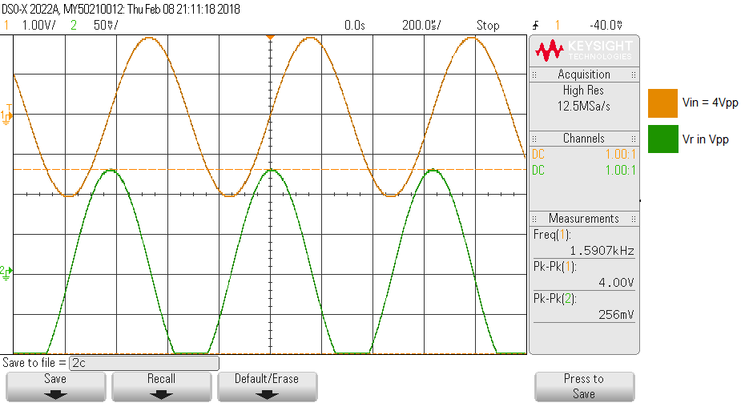

Graph 3: Measurements of Vin(t) and Vr(t) at F = 1590Hz

Vin(t) = 4.0Vpp, Vr(t) = 0.256Vpp, Gain = 0.064

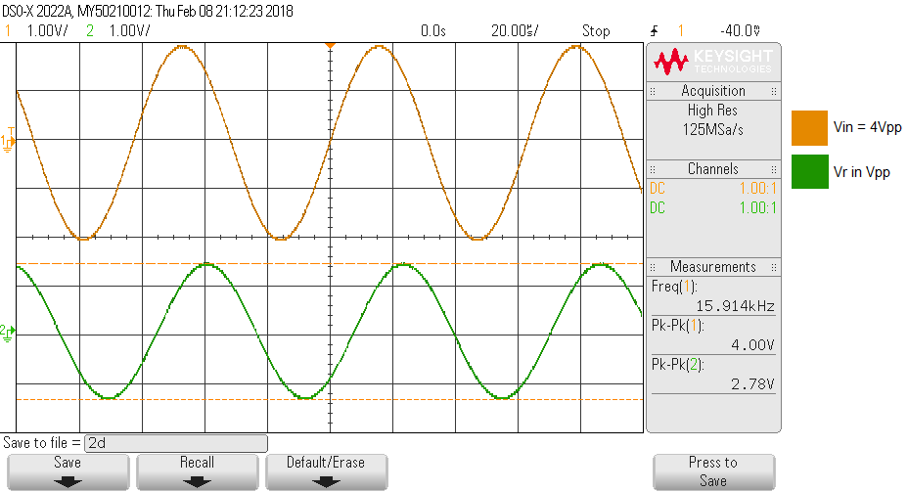

Graph 4: Measurements of Vin(t) and Vr(t) at F = 15.9 kHz

Vin(t) = 4.0Vpp, Vr(t) = 2.78Vpp, Gain = 0.695

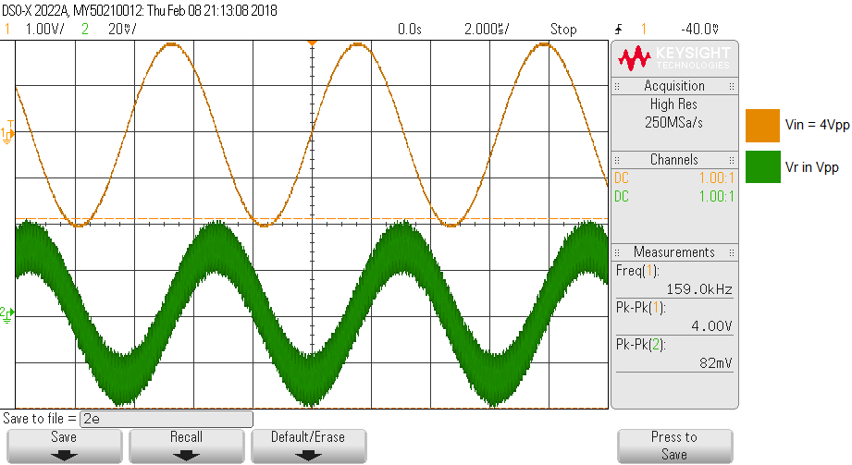

Graph 5: Measurements of Vin(t) and Vr(t) at F = 159 kHz

Vin(t) = 4.0Vpp, Vr(t) = 0.0082Vpp, Gain = 0.00205

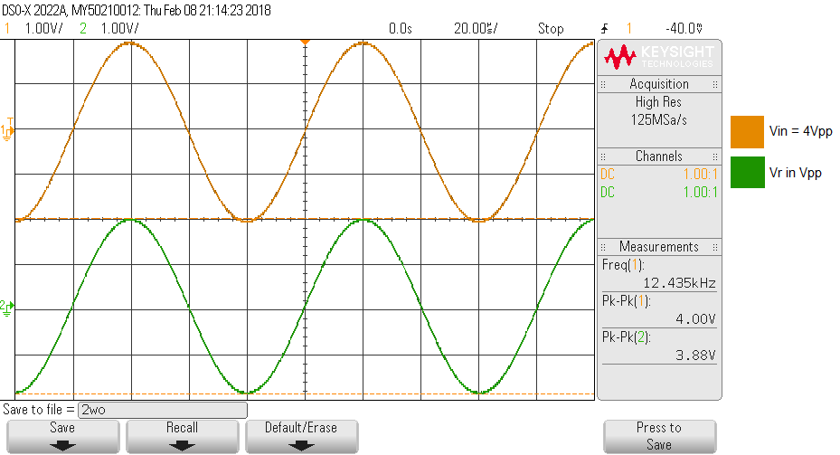

Graph 6: Measurements of Vin(t) and Vr(t) at F = 12.435 kHz (resonance frequency)

Vin(t) = 4.0Vpp, Vr(t) = 3.88Vpp, Gain = 0.97

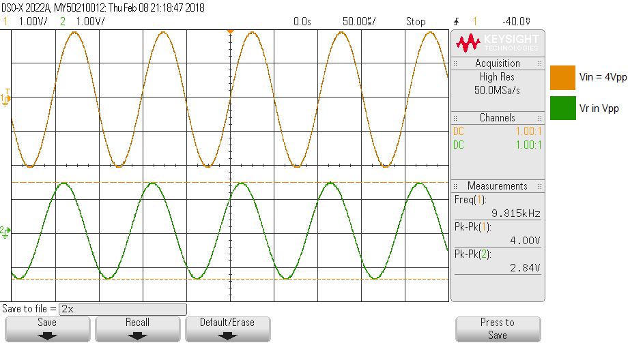

Graph 7: Measurements of Vin(t) and Vr(t) at F = 9.815 kHz (lower dB)

Vin(t) = 4.0Vpp, Vr(t) = 2.84Vpp, Gain = 0.71

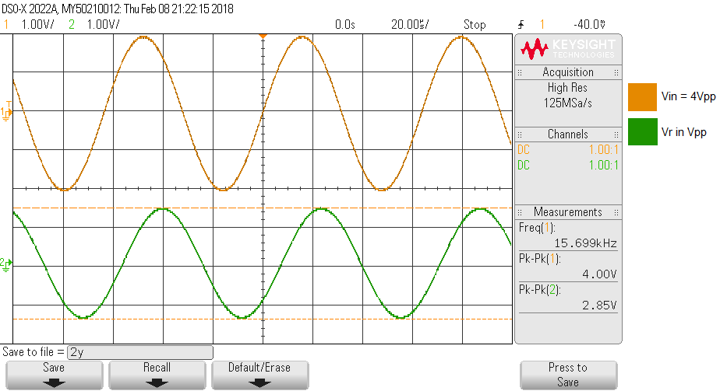

Graph 7: Measurements of Vin(t) and Vr(t) at F = 15.699 kHz (higher dB)

Vin(t) = 4.0Vpp, Vr(t) = 2.85Vpp, Gain = 0.71

Table 1: Summary of Circuit 1

|  |  |  |  |
| --- | --- | --- | --- |
| Frequency | Vin | Vr | Gain |
| 15.9 Hz | 4 Vpp | 0.0027 Vpp | 0.000675 |
| 159 Hz | 4 Vpp | 0.0232 Vpp | 0.0058 |
| 1590 Hz | 4 Vpp | 0.256 Vpp | 0.064 |
| 15.9 kHz | 4 Vpp | 2.78 Vpp | 0.695 |
| 159 kHz | 4 Vpp | 0.0082 Vpp | 0.00205 |
| Wo = 12.427 kHz | 4 Vpp | 3.88 Vpp | 0.97 |
| 3db1 = 9.82 kHz | 4 Vpp | 2.84 Vpp | 0.71 |
| 3db2 = 15.7 kHz | 4 Vpp | 2.85 Vpp | 0.71 |

Graph 8: Plot of the measurements

**Part 3**

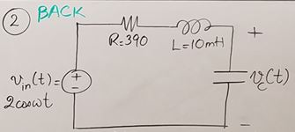

Figure 2: Circuit 2

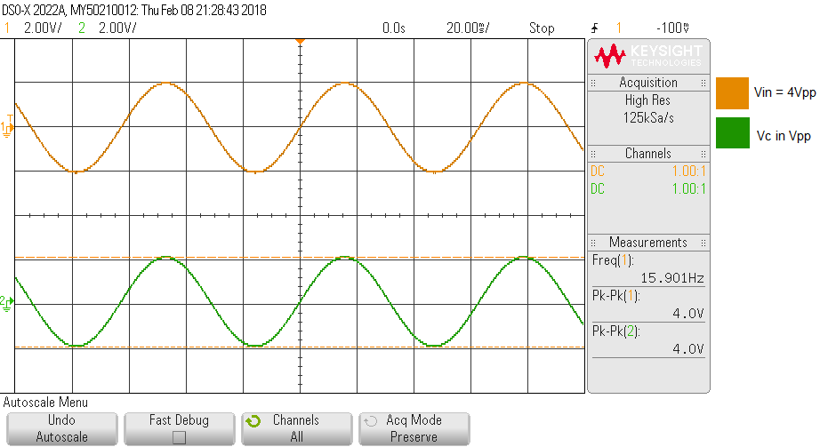

Graph 9: Measurements of Vin(t) and Vc(t) at F = 15.9 Hz

Vin(t) = 4.0Vpp, Vr(t) = 4.0Vpp, Gain = 1.0

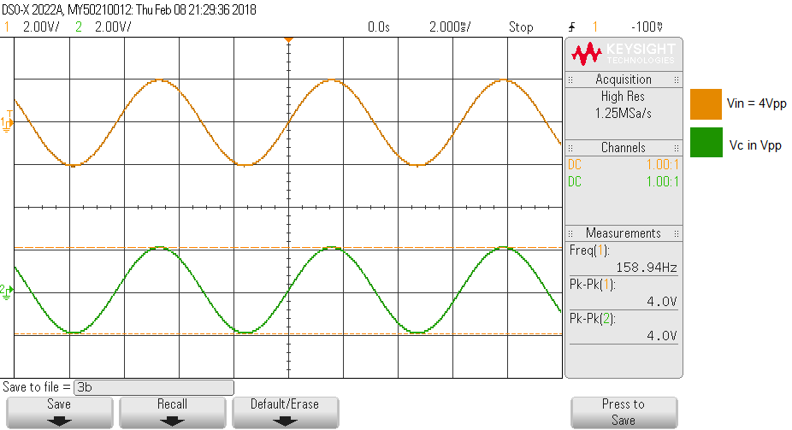

Graph 10: Measurements of Vin(t) and Vc(t) at F = 159 Hz

Vin(t) = 4.0Vpp, Vr(t) = 4.0Vpp, Gain = 1.0

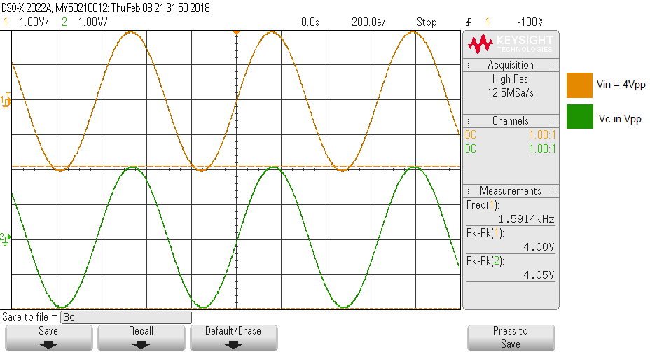

Graph 11: Measurements of Vin(t) and Vc(t) at F = 1590 Hz

Vin(t) = 4.0Vpp, Vr(t) = 4.05Vpp, Gain = 1.0125

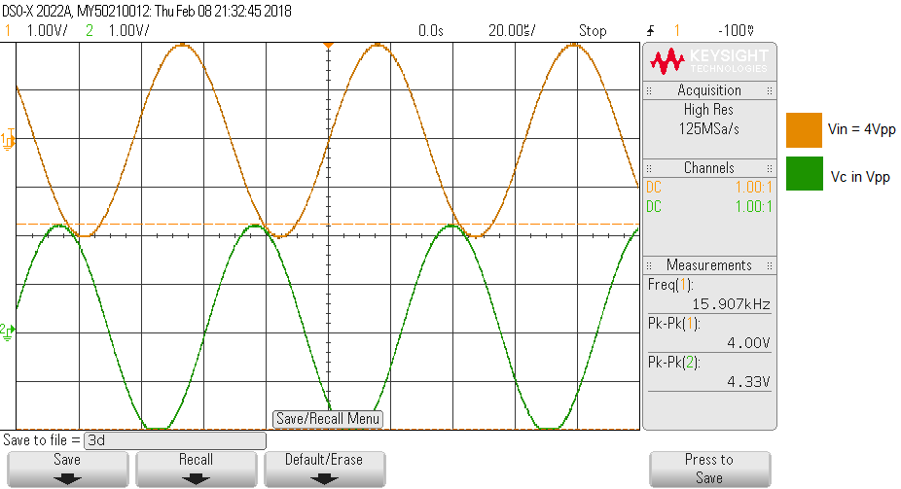

Graph 12: Measurements of Vin(t) and Vc(t) at F = 15.9 kHz

Vin(t) = 4.0Vpp, Vr(t) = 4.33Vpp, Gain = 1.0825

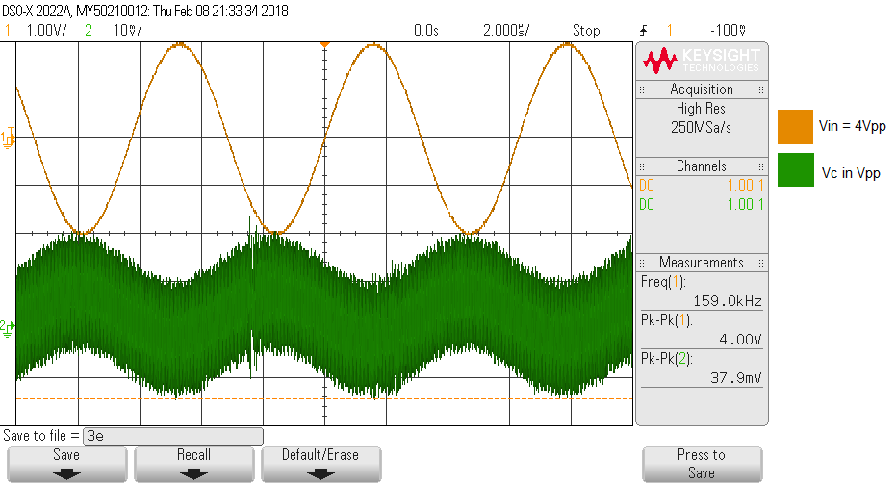

Graph 13: Measurements of Vin(t) and Vc(t) at F = 159 kHz

Vin(t) = 4.0Vpp, Vr(t) = 0.0037 Vpp, Gain = 0.000925

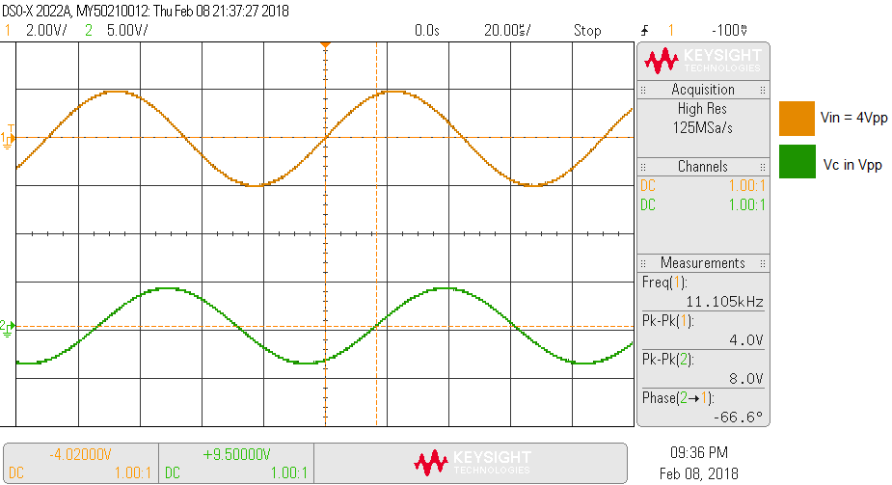

Graph 14: Measurements of Vin(t) and Vc(t) at F = 11.105 kHz (Resonance)

Vin(t) = 4.0Vpp, Vr(t) = 8.0 Vpp, Gain = 2.0

Phase at resonance = -66.6°

Table 2: Summary of Circuit 2

|  |  |  |  |
| --- | --- | --- | --- |
| Frequency | Vin | Vc | Gain |
| 15.9 Hz | 4 Vpp | 4.0 Vpp | 1.0 |
| 159 Hz | 4 Vpp | 4.0 Vpp | 1.0 |
| 1590 Hz | 4 Vpp | 4.05 Vpp | 1.0125 |
| 15.9 kHz | 4 Vpp | 4.33 Vpp | 1.0825 |
| 159 kHz | 4 Vpp | 0.0037 Vpp | 0.000925 |
| Wo = 11.105 kHz | 4 Vpp | 8.0 Vpp | 2.0 |

Figure 3: Expected Gain graph of circuit 2

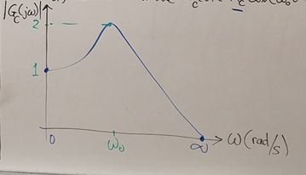

Graph 15: Actual Gain graph of circuit 2

**Post Lab:** Attached at the end of lab.